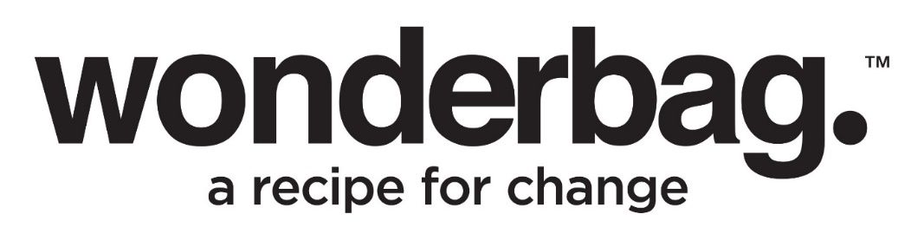

Press Release
For immediate release

WonderbagDirect brings hope to South Africans in despair from loadshedding
The demand for alternative energy and products that are loadshedding-friendly and affordable has increased astronomically in the past few months with electricity becoming more and more sparse and access to funds also being scarce. The beloved South African born Wonderbag is offering an easy to access, low cost, low impact lifeline called WonderbagDirect to help locals cope with the struggles of constant loadshedding. For only R170, any South African with internet access can order two of the award-winning non-electric heat-retention cookers through www.mywonderbag.co.za. And, with no extra delivery cost, the Wonderbags will be sent to a nearby Pargo collection point for your convenience.
“In line with our mission to get Wonderbags to people who need it the most, at an affordable price, we are excited to launch WonderbagDirect to help alleviate the stress of trying to cook with limited or no power. We have been able to reduce the cost of the bags by leveraging off our Recipe for Change carbon credit project. Anyone who buys subsidised bags through our simple, online purchasing portal will have their data and Wonderbag usage recorded and stored securely in compliance with the POPI Act, which in turn contributes to the project’s overall carbon credits accrual,” explains Sarah Collins, Founder and CEO of Wonderbag.
With this initiative forming part of Wonderbag’s Recipe for Change carbon-offset project, it is a community-focused project fighting climate change while tackling the United Nation’s 17 Sustainable Development Goals. Collins believes by making Wonderbags more accessible, progress towards a cleaner, sustainable and equitable future is being accelerated.
“We genuinely want to make a positive impact on the lives of any and every South African as well as on the health of our planet. Historically we have seen the biggest impact being felt by people working on farms, in remote locations and without services,” says Collins.
WonderbagDirect was launched in late 2022 with the aim of making Wonderbags accessible to more people regardless of location. Wonderbag is currently partnering with various logistics companies, including Pargo, to find the most affordable and accessible solutions for distributing Wonderbags across rural, semi-rural, and urban areas throughout the country. Further to this, the WonderbagDirect’s online platform developed by Racvert is simple and user-friendly while also being highly efficient. Ultimately the objective of WonderbagDirect is to open up access to Wonderbags to anyone, anywhere, at any time, allowing Wonderbag to reach more people than ever before. “We believe more organisations can follow Wonderbag's example for using software to create and measure benefits for communities,” says Robert Louw, Managing Director at Racvert.

“Although Wonderbags are easily available online using safe and secure payment options, we have also considered the possible limitations of some people not knowing how to buy online, or not having access to a smartphone or a bank card. To be as inclusive as possible, we are also growing our community support via WonderWomen who are part of their communities to increase accessibility to all South Africans. WhatsApp support via the WonderCare team will also empower people to take the leap to buy online via WonderbagDirect. Lack of access to phones is going to be a thing of the past one day, so until then we believe this model by Wonderbag will support the online shopping revolution for ALL South Africans,” adds Collins.
Wonderbag was voted as one of the world’s Top 50 Genius Companies Leading into The Future by Time Magazine, and was more recently short-listed in 2022 as the only South African-based company in line to win the prestigious and global Food Planet Prize award. Some of the many wonders of the award-winning Wonderbag that make it the quintessential cooking aid, includes saving money, energy, water, and time. Each Wonderbag saves 1000 litres of water and 500 kilowatts of electricity, making the estimated savings per bag an astounding R1190, and R2380 for two bags. Over one year it is estimated that a Wonderbag user will have saved 1 ton of carbon that would have normally been emitted through regular cooking methods.
Wonderbag offers the world a game-changing initiative to address the climate crisis through food solutions and was invented by South African social entrepreneur and humanitarian, Sarah Collins, in 2008. According to Collins, this simple yet revolutionary invention was driven by a yearning for equality and social justice that has since developed into an entrepreneurial solution to many of the world’s humanitarian and environmental issues by changing the way people cook.
To purchase a WonderbagDirect deal of two Wonderbags for just R170 with free delivery across South Africa, visit www.mywonderbag.co.za . It also comes with a free recipe book including instructions on how to use the heat-retention cooker. Wonderbag’s dedicated WonderCare team is also available to answer any questions customers may have on the following communication lines:
• WhatsApp – 069 160 7164
• Landline – 031 563 8220
• Email – wondercare@wonderbagworld.com

ENDS

WORDS  DISTRIBUTED  IMAGES  DATE | :  :  :  : | 804  On behalf Wonderbag  Images of Wonderbag & visual of Sarah Collins  March 2023

Notes to Editor

About Wonderbag
The Wonderbag is a revolutionary, non-electric, heat retention cooker that allows food that has been brought to the boil by conventional methods, to continue cooking for up to 8 hours, without using an additional energy source. Not only is the Wonderbag a revolution in the kitchen, but it is also a recipe for social change. The world has embraced the Wonderbag because of its environmental attributes and particularly its social contributions – that includes it being coined by carbon and climate change experts as, “the only scalable carbon offset project in existence”.
Wonderbag is one of the fastest growing registered carbon projects in Africa and is changing the model of aid as we know it. In South Africa, Natural Balance has registered the Wonderbag project as a carbon offset project, unique to any other carbon offset project in South Africa. The Wonderbag offset has significant sustainable development benefits.
Wonderbag was founded in South Africa in 2008 by local entrepreneur and social activist, Sarah Collins, and the product was born out of a practical desire to continue cooking during a bout of Eskom load shedding. Since opening its doors, the company has grown exponentially, and this local product has crossed over borders into various overseas markets.
Connect with Wonderbag on…

Twitter and Instagram: @TheWonderbag
Facebook: Facebook.com/TheWonderbag
Website: www.wonderbagworld.com

For more information or visuals, please contact Janna Strang on janna@rainmakermarketing.co.za or 082 551 3865

